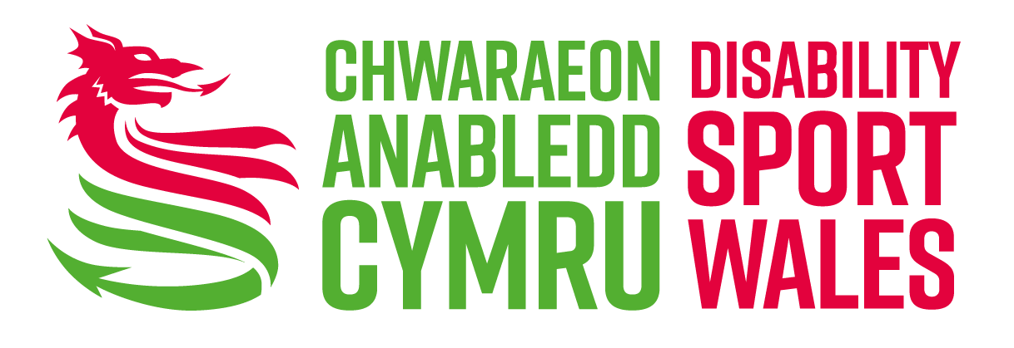
Easy Read Survey

Involvement in Physical Activity Survey

 | We are Disability Sport Wales.
 | We want to know about your experiences of physical activity.
 | When we ask people to tell us about their experiences, we also ask them about themselves.
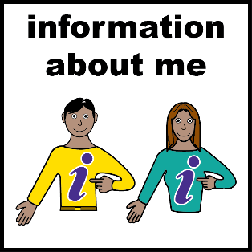 | We do this to make sure all types of people are getting the chance to tell us about their experiences.
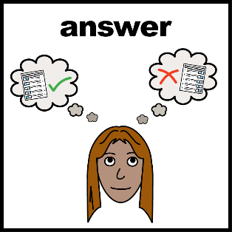 | To help us with this we would like you to fill out this form. And give us information about yourself.
 | We will keep your information private.
 | We will not show anyone your information without asking you first.
 | We will not give your information to other organisations.
 | If you would like to know more you can read our Equity Policy.
 | You can call us on 0300 3003115 and we will send you a copy. Or you can read it on our website: www.disabilitysportwales.com

Thank you.

Questions

- How do you describe yourself?
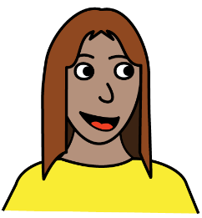 | Female | ☐
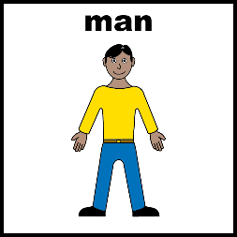 | Male | ☐
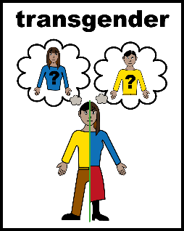 | Trans - people who feel different inside in some way to the gender they were born as. | ☐
 | I do not want to say | ☐
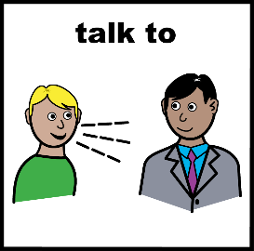 | Other | ☐
 | If you said other, please tell us how you describe yourself:

- Do you find every day activities difficult because of a:
- health condition
- illness
- or disability
that has lasted or will last for 1 year or more?

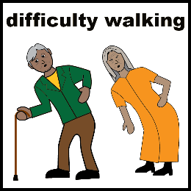 | Yes. I find everyday activities very difficult. I find life hard. | ☐
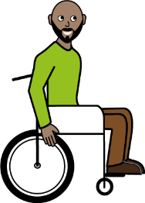 | Yes. I find everyday activities quite difficult. I find life hard sometimes. | ☐
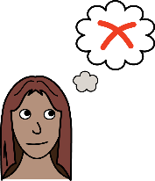 | No | ☐
 | I do not want to say | ☐

- What date is your birthday?

- Before Covid-19, did you take part in physical activity?
☐
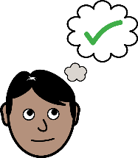
Yes

☐
No

☐
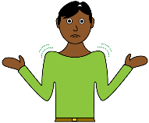
Not sure

- Before Covid-19, what type of physical activity did you do? Select as many as you like.
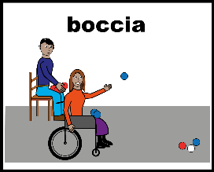
☐
☐
At a club

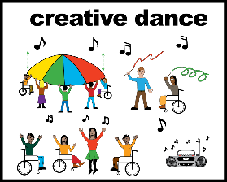
With friends

☐
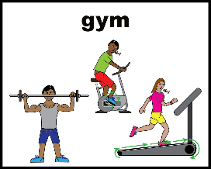
On my own

☐
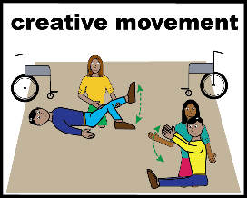
At home
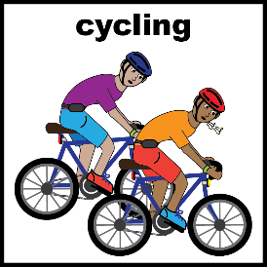
☐

Outdoor activities

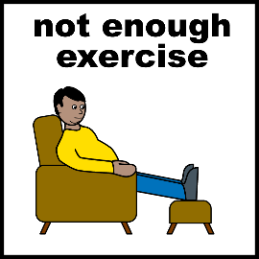
☐

None

- Recently, what physical activity have you been able to do? Select as many as you like.
☐
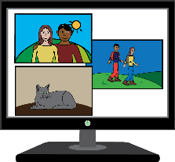
Video exercises

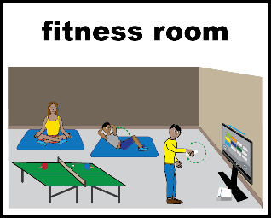
☐

Online activities. Via Zoom, Skype, or YouTube etc.

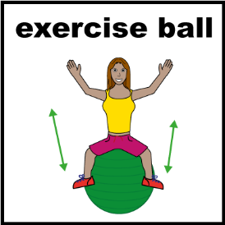
☐

At home exercise

☐
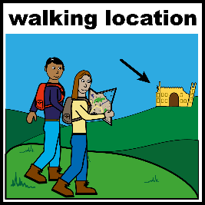
Outdoor activities

☐

None

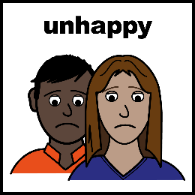
- What challenges have you experienced when trying to do physical activity? Select as many as you like.
☐

Not interested
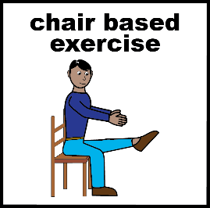
☐

No activities suitable for my disability or impairment

☐
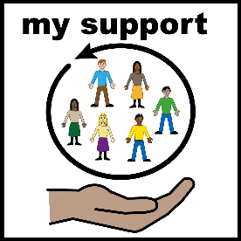

No support available

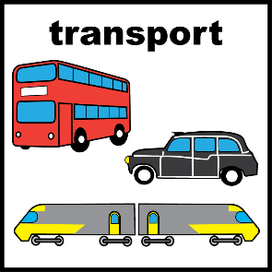
☐

No transport

☐
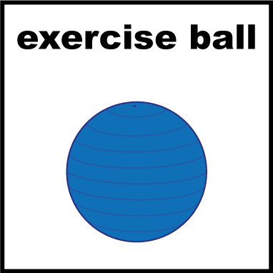

No equipment

☐
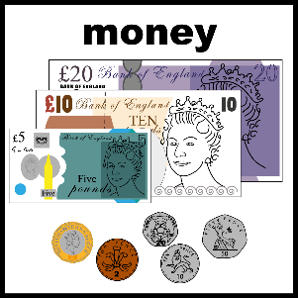
Cost

- How could your physical activity experience be improved? Select as many as you like.
☐
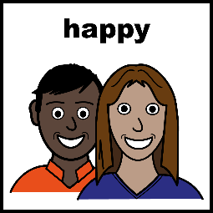

Activities I am interested in

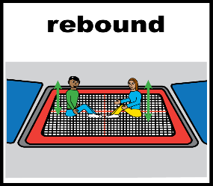
☐

More activities suitable for my disability or impairment

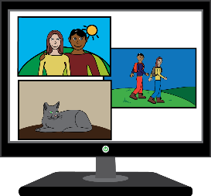
☐

Access to a computer

☐

Transport made available

☐

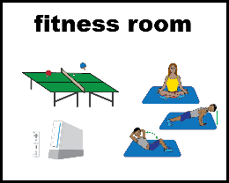
Equipment

☐

Being able to take part with friends

Thank you for completing the survey if you
would like to speak to us please
Phone: 0300 3003115 or
Email: office@disabilitysportwales.com

